8 BIT ADDITON

AIM:

EXPNO:1

To write an assembly language program to implement 8 bit addition using 8085 processor

ALGORITHM:

1)start the program by loading the first data into the accumulator.

2)move the data to a register

3)Get the second data and load it into the accumulator

4)Add the two register contents.

5)check for carry.

6)store the value of sum and carry into the memory location.

7)Halt.

PROGRAM

LDA 8500

MOV B,A

LDA 8501

ADD B

STA 8502

RST 1

INPUT:

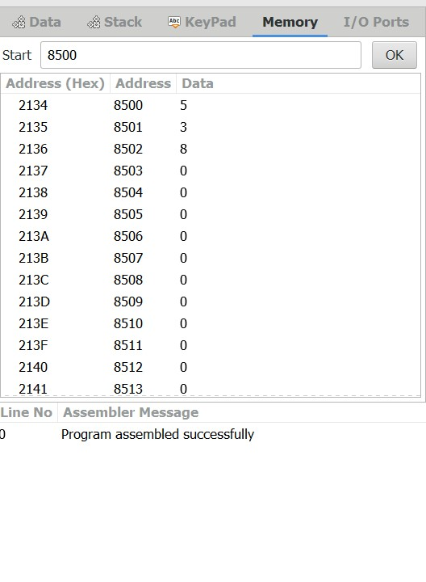

OUTPUT:

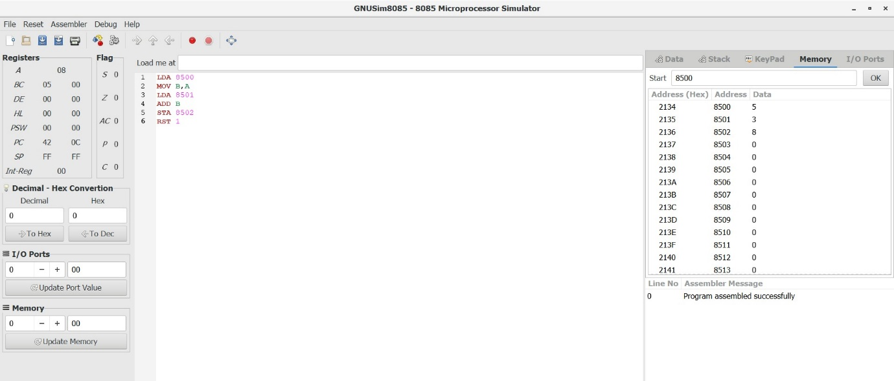

RESULT:

Thus the program was excuted successfully using 8085 program simulator.